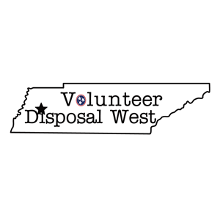
Name:____________________________________________
Address: ___________________________________________
Phone Number: _____________________
Email Address:(required for billing) _________________________
Service Requested:
All new enrollments have a onetime $10.00 enrollment fee, to be charged at the time of enrollment. All customers requesting a container will have a onetime $25 can delivery/lifetime maintenance fee.
- ___ Backdoor Pick-Up ($38/month no cart provided) *I have read and agree to the backdoor terms of service clause. ____ (initial).
- ___ Curbside Pick-Up ($25/month with cart provided)
- ___ 2 Cart Curbside Pick-Up ($40/month with carts provided)
- ___ 2 yard Dumpster ($80/month)
- ___ 4 yard Dumpster ($115/month)
- ___ 6 yard Dumpster ($150/month)
*Effective July 1st, 2022, all accounts will have a Fuel Recovery Fee applied monthly.
Method of Payment: Auto Draft on 1st of every month
    - Bank account – (preferred method, no fees applied)
      - Routing Number _________________________
      - Account Number_________________________
or
    - Debit/Credit Card ($3.00 Monthly Fee Applied for all card payments)
      - Card Number ____________________________
        - Exp. Date __________________________
Mail, Email, or Text completed form to: P.O. Box 418, Gadsden, TN 38337 volunteerdisposalwest@gmail.com (731) 345-1421
Once form is received account will be created and the monthly service rate and enrollment fee and can delivery fee will be charged to the provided method of payment. Can or dumpster will then be delivered for curbside and commercial services. Service will start the following week.
Signature: _________________________ Date: _____________
By signing I authorize Volunteer Disposal West to debit service fees as listed above from the provided payment method monthly and I have read and reviewed the Terms of Service at www.volunteerdisposalwest.com.

